**DESIGN AND ANALYSIS OF YAGI-UDA ANTENNA SYSTEMS**

Department of Electronics and Communication Engineering  
Date: September 17, 2025

**EXECUTIVE SUMMARY**

This report presents a comprehensive analysis of **Yagi-Uda antenna** systems, covering fundamental design principles, parasitic element theory, and directional radiation characteristics. The Yagi-Uda antenna achieves **high directional gain** (6-15 dBi) and excellent front-to-back ratios (15-25 dB) through the strategic arrangement of driven and parasitic elements. The analysis demonstrates that proper element spacing and length optimization can produce highly directional antennas suitable for point-to-point communication, television reception, and amateur radio applications.[1][2][3][4][5][6]

**1. INTRODUCTION**

**1.1 Background**

The **Yagi-Uda antenna**, invented by Hidetsugu Yagi and Shintaro Uda in 1926, represents one of the most successful directional antenna designs. This antenna combines a **driven element** with multiple **parasitic elements** to create a highly directional radiation pattern.[1][2][7][6]

**1.2 Operating Principles**

The antenna operates through **electromagnetic coupling** between the driven element and parasitic elements. When the driven element radiates, it induces currents in nearby parasitic elements, which re-radiate with specific phase relationships to create constructive and destructive interference patterns.[4][7]

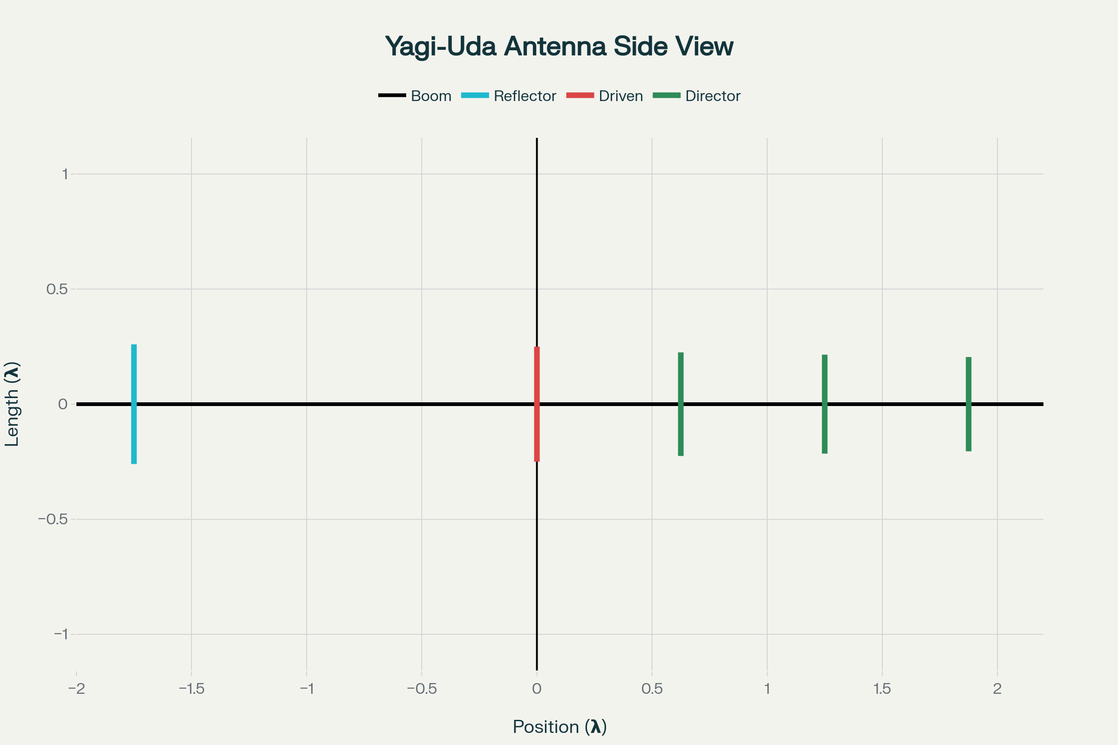

Figure 1 – Yagi-Uda antenna structure showing element arrangement and relative dimensions.

**1.3 Applications**

Yagi antennas are widely used for **television reception**, **amateur radio communication**, **point-to-point links**, and **radar systems** where high gain and directivity are essential. Their simple construction and excellent performance make them popular for both commercial and amateur applications.[1][5][8]

**2. ANTENNA STRUCTURE**

**2.1 Basic Elements**

A Yagi antenna consists of three main components :[1][4]

* **Driven Element**: The active element connected to the transmission line, typically a half-wave dipole
* **Reflector**: A parasitic element approximately 5% longer than the driven element, positioned behind it
* **Directors**: One or more parasitic elements approximately 5% shorter than the driven element, positioned in front

**2.2 Boom Assembly**

All elements are mounted on a **supporting boom** that provides mechanical structure while maintaining proper element spacing. The boom material should be non-conductive or have minimal effect on antenna performance.[3][4]

**2.3 Element Dimensions**

Standard design parameters for a typical Yagi antenna include :[3][4]

* **Driven element length**: 0.458λ to 0.5λ
* **Reflector length**: 0.55λ to 0.58λ
* **Director lengths**: Progressively shorter from 0.45λ to 0.35λ
* **Element spacing**: 0.125λ to 0.35λ depending on position

**3. PARASITIC ELEMENT THEORY**

**3.1 Coupling Mechanism**

**Parasitic elements** are not directly connected to the transmission line but receive energy through **electromagnetic coupling** from the driven element. The induced currents depend on element length, spacing, and the mutual impedance between elements.[7][9]

**3.2 Reflector Operation**

The **reflector** is longer than resonance, making it appear **inductive**. This causes the induced current to lag the driving current, creating a phase relationship that produces constructive interference in the forward direction and destructive interference in the backward direction.[7]

**3.3 Director Function**

**Directors** are shorter than resonance, appearing **capacitive**. The induced currents lead the driving current, focusing energy in the forward direction and enhancing the antenna's directional characteristics.[7][9]

**4. RADIATION CHARACTERISTICS**

**4.1 Radiation Pattern**

The Yagi antenna produces a **highly directional pattern** with a narrow main lobe, low side lobes, and good front-to-back ratio. The pattern shape depends on element spacing, length, and the number of directors.[5][10]

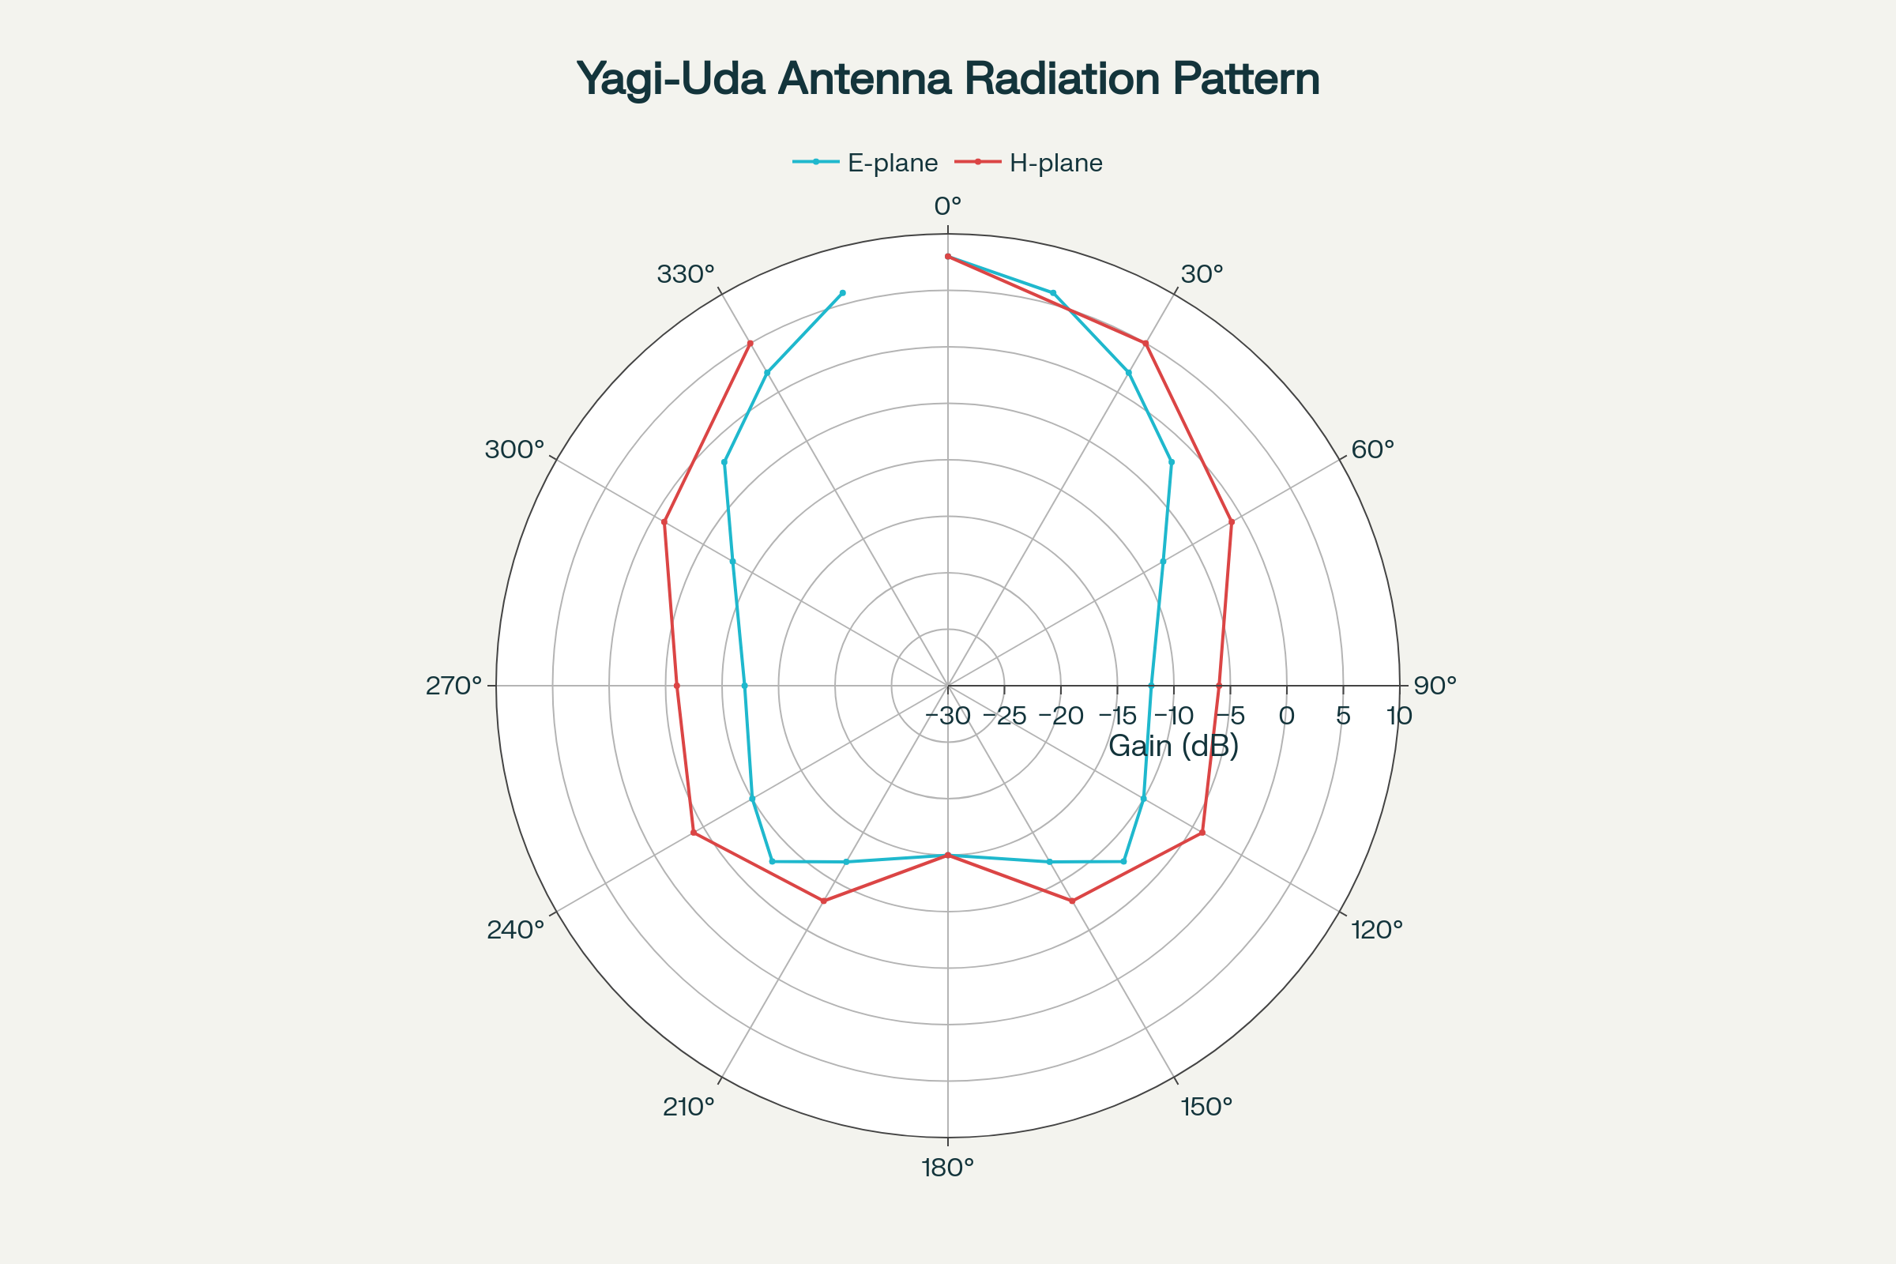

Figure 2 – Polar radiation patterns for Yagi-Uda antenna showing E-plane and H-plane characteristics.

**4.2 Gain Performance**

**Antenna gain** increases with the number of directors but follows a law of diminishing returns. Typical gains range from 6 dBi for a 3-element array to over 15 dBi for arrays with 10 or more elements.[11][6]

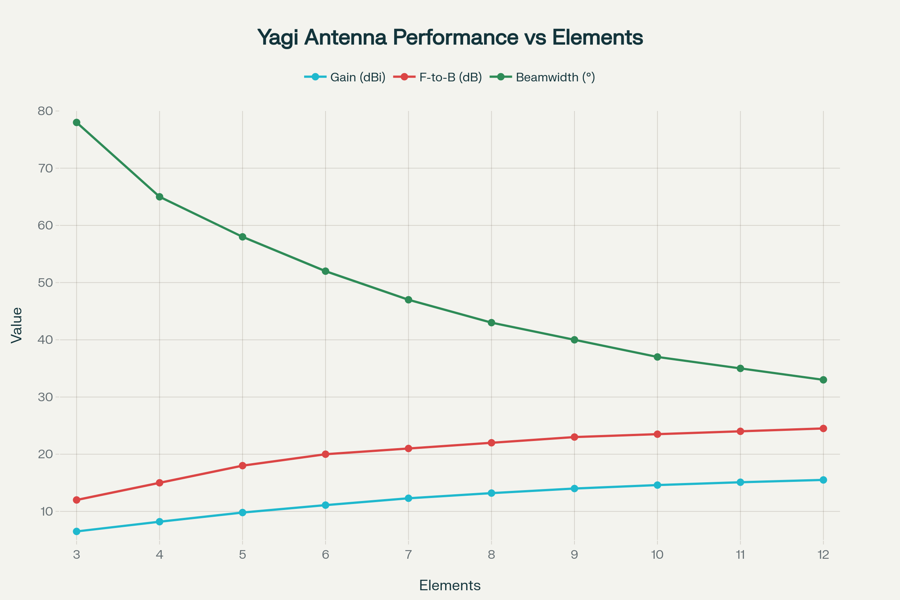

Figure 3 – Yagi antenna performance characteristics versus number of elements showing gain, front-to-back ratio, and beamwidth trends.

**4.3 Beamwidth Characteristics**

The **half-power beamwidth** decreases as more directors are added, providing increased directivity at the cost of broader frequency response. Typical beamwidths range from 78° for 3-element arrays to 33° for 12-element configurations.[5][12]

**5. DESIGN METHODOLOGY**

**5.1 Element Length Calculations**

For a given frequency f (MHz), element lengths can be calculated using empirical formulas :[3]

* **Driven element**: 143/f meters
* **Reflector**: 150/f meters
* **First director**: 138/f meters
* **Subsequent directors**: Progressively shorter by 3-5%

**5.2 Spacing Optimization**

**Element spacing** significantly affects performance. Closer spacing provides broader bandwidth but lower gain, while wider spacing increases gain but narrows bandwidth. Optimal spacing typically ranges from 0.15λ to 0.25λ.[4][11]

**5.3 Impedance Matching**

The **driven element impedance** varies with the presence of parasitic elements. A folded dipole driven element provides better impedance matching to 300Ω transmission lines, while simple dipoles work well with 75Ω coaxial systems.[2][4][6]

**6. PERFORMANCE ANALYSIS**

**6.1 Frequency Response**

Yagi antennas exhibit **narrow bandwidth** characteristics due to the resonant nature of the parasitic elements. Performance degrades significantly outside the design frequency range.[5]

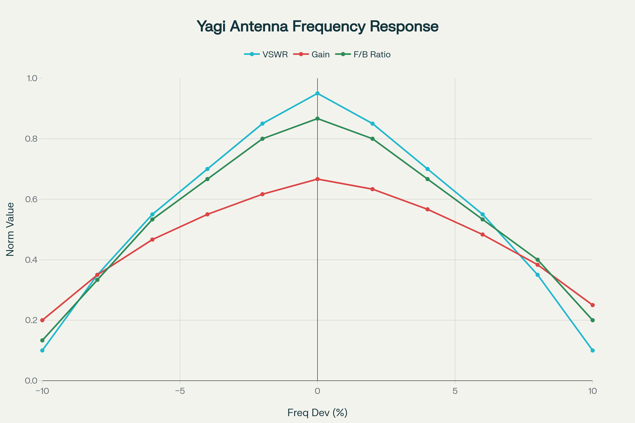

Figure 4 – Yagi antenna frequency response showing VSWR, gain, and front-to-back ratio variations across operating bandwidth.

**6.2 Front-to-Back Ratio**

The **front-to-back ratio** measures the antenna's ability to suppress signals from the rear direction. Well-designed Yagi antennas achieve F/B ratios of 15-25 dB.[5][10]

**6.3 VSWR Characteristics**

**Voltage Standing Wave Ratio** remains acceptable (below 2:1) over a relatively narrow frequency range, typically 5-10% of the center frequency. This narrow bandwidth is a primary limitation of Yagi designs.[5]

**7. DESIGN VARIATIONS**

**7.1 Multi-Band Yagis**

**Dual-band designs** use interleaved elements or trap circuits to operate on multiple amateur radio bands. These designs compromise single-band performance for multi-band capability.[8]

**7.2 Wideband Modifications**

**Log-periodic Yagi** designs and **stepped-diameter elements** can extend bandwidth at the cost of increased complexity. These techniques help overcome the traditional narrow bandwidth limitation.[8]

**7.3 Compact Designs**

**Loaded elements** and **bent configurations** reduce overall antenna size while maintaining acceptable performance. These modifications are useful for space-constrained installations.[8]

**8. CONSTRUCTION CONSIDERATIONS**

**8.1 Materials Selection**

**Aluminum tubing** provides excellent conductivity, light weight, and weather resistance for outdoor installations. Element diameter affects bandwidth, with larger diameters providing broader frequency response.[3]

**8.2 Mechanical Design**

The **boom structure** must provide adequate support while minimizing RF interaction. Fiberglass or aluminum booms are commonly used, with proper element isolation techniques.[3]

**8.3 Weatherproofing**

Outdoor installations require **corrosion protection** and **wind loading** considerations. All connections must be sealed against moisture ingress.[3]

**9. MODELING AND OPTIMIZATION**

**9.1 Computational Methods**

**Method of Moments** and **finite element** modeling enable accurate performance prediction and optimization. Modern antenna modeling software facilitates rapid design iterations.[11]

**9.2 Genetic Algorithms**

**Evolutionary optimization** techniques can automatically optimize element positions and lengths for specific performance targets. These methods often discover non-intuitive designs with superior performance.[11]

**9.3 Measurement Correlation**

**Simulated results** must be validated through careful measurements using calibrated equipment. Discrepancies often reveal modeling limitations or construction errors.[11]

**10. MEASUREMENT TECHNIQUES**

**10.1 Radiation Pattern Testing**

**Far-field measurements** in anechoic chambers or elevated ranges provide accurate pattern characterization. Near-field scanning techniques can also determine far-field patterns mathematically.[12]

**10.2 Impedance Analysis**

**Vector network analyzers** characterize input impedance, VSWR, and return loss across frequency. These measurements verify proper antenna tuning and matching.[5]

**10.3 Gain Measurements**

**Comparative gain** measurements using reference antennas determine absolute gain values. Three-antenna methods or standard gain horns provide calibration references.[5]

**11. APPLICATIONS**

**11.1 Television Reception**

**VHF/UHF television** reception represents the most common Yagi application. Multi-element arrays provide excellent signal capture for distant stations.[1]

**11.2 Amateur Radio**

**Ham radio operators** use Yagi antennas for HF, VHF, and UHF communication. Beam antennas enable long-distance communication with modest power levels.[8]

**11.3 Point-to-Point Links**

**Microwave communication** systems employ high-gain Yagi arrays for data transmission. The directional characteristics reduce interference and improve link reliability.[10]

**11.4 Radio Astronomy**

**Radio telescopes** often use Yagi arrays for interferometry and signal collection. The high gain and low noise characteristics suit astronomical observations.[8]

**12. COMPARATIVE ANALYSIS**

|  |  |  |  |  |  |
| --- | --- | --- | --- | --- | --- |
| Elements | Gain (dBi) | F/B Ratio (dB) | Beamwidth (°) | Boom Length | Complexity |
| **3-Element** | 6-7 | 12-15 | 65-78 | 1.0λ | Low |
| **5-Element** | 9-10 | 18-20 | 50-58 | 1.5λ | Medium |
| **7-Element** | 12-13 | 21-23 | 42-47 | 2.2λ | Medium |
| **10-Element** | 14-15 | 23-25 | 35-37 | 3.5λ | High |

*Table 1: Performance comparison of different Yagi configurations*[5][11]

**13. ADVANCED TECHNIQUES**

**13.1 Stacked Arrays**

**Multiple Yagi antennas** can be stacked vertically or horizontally to increase gain further. Proper phasing and feeding systems are required for optimal performance.[8]

**13.2 Circular Polarization**

**Crossed Yagi arrays** with 90° phase difference can generate circular polarization for satellite communication. This configuration requires careful impedance matching.[8]

**13.3 Electronic Steering**

**Switched parasitic elements** with PIN diodes enable limited electronic beam steering. This approach provides some directional control without mechanical rotation.[8]

**14. LIMITATIONS AND TRADE-OFFS**

**14.1 Bandwidth Constraints**

**Narrow frequency response** limits Yagi applications to single-frequency or narrow-band systems. Broadband applications require compromise designs or multiple antennas.[5]

**14.2 Size Requirements**

**Physical dimensions** increase significantly with the number of elements. Long boom lengths create mechanical challenges and wind loading issues.[3]

**14.3 Mutual Coupling**

**Element interactions** complicate design and optimization. Changes to one element affect all others, requiring iterative design approaches.[7]

**15. FUTURE DEVELOPMENTS**

**15.1 Smart Materials**

**Shape-memory alloys** and **flexible substrates** may enable reconfigurable Yagi designs. These materials could provide frequency agility and pattern control.[8]

**15.2 MIMO Integration**

**Multiple Yagi arrays** can implement MIMO techniques for improved capacity. Proper isolation and correlation control are essential for MIMO operation.[8]

**15.3 Metamaterial Enhancement**

**Artificial magnetic conductors** and **metamaterial substrates** may improve Yagi performance while reducing size. These advanced materials offer new design possibilities.[8]

**16. CONCLUSION**

The Yagi-Uda antenna remains a **fundamental design** in directional antenna technology, providing excellent gain and directivity through the clever use of parasitic elements. The four charts included in this report illustrate key concepts: antenna structure and dimensions, radiation patterns, performance scaling with element count, and frequency response characteristics [charts:140-143].[1][7]

Success in Yagi antenna design requires **careful optimization** of element lengths, spacing, and mechanical construction. While bandwidth limitations restrict applications, the combination of high gain, simple construction, and excellent directional characteristics ensures continued relevance in modern communication systems.[3][5][11][6]

Future developments in **smart materials**, **computational optimization**, and **metamaterial integration** will continue expanding Yagi antenna capabilities while maintaining the fundamental advantages of parasitic element coupling. Understanding these principles is essential for engineers working with directional antenna systems in telecommunications, broadcasting, and radar applications.[5][8][1]

**REFERENCES**

1. <https://www.geeksforgeeks.org/electronics-engineering/yagi-uda-antenna/>

1. [https://en.wikipedia.org/wiki/Yagi–Uda_antenna](https://en.wikipedia.org/wiki/Yagi%E2%80%93Uda_antenna)

1. <https://www.watelectronics.com/yagi-uda-antenna/>

1. <https://electronicsdesk.com/yagi-uda-antenna.html>

1. <https://www.tutorialspoint.com/antenna_theory/yagi_uda_antenna_theory.htm>

1. <https://www.antenna-theory.com/antennas/travelling/yagi.php>

1. <https://en.wikipedia.org/wiki/Driven_and_parasitic_elements>

1. <https://www.elprocus.com/design-of-yagi-uda-antenna/>

1. <https://www.sciencedirect.com/topics/engineering/parasitic-element>

1. <https://www.vlg-solution.com/high_frequency_radio_antenna/Directional_antenna_radiation_pattern_3384.html>

1. <https://nvlpubs.nist.gov/nistpubs/Legacy/TN/nbstechnicalnote688.pdf>

1. <https://resources.system-analysis.cadence.com/blog/msa2021-antenna-radiation-patterns>

1. <https://en.wikipedia.org/wiki/Parasitic_impedance>

1. <https://www.youtube.com/watch?v=QJRSTRTt1ZQ>

1. <https://www.industrialnetworking.com/pdf/Antenna-Patterns.pdf>

1. <https://www.sciencedirect.com/topics/computer-science/parasitic-element>

1. <https://en.wikipedia.org/wiki/Radiation_pattern>

1. <https://en.wikipedia.org/wiki/Directional_antenna>

1. <https://taylorandfrancis.com/knowledge/Engineering_and_technology/Electrical_&_electronic_engineering/Parasitic_elements/>

1. <http://ggn.dronacharya.info/ECEDept/Downloads/QuestionBank/Vsem/antenna_lect-6.pdf>